COLLEGE OF COMPUTER STUDIES
CS0019 MODELING AND SIMULATION
EXERCISE ON SIMULINK
Simple Arithmetic in Simulink

Name: Dawn Andrei Pamesa
Section: TS31
Date: October 23, 2026
Simulink Diagram with Sample Input Values and Output
The diagram has two Constant blocks (Input A = 20 and Input B = 5) that feed four blocks: Add, Subtract, Product (multiplication) and Product with a divide input. Each result goes to a Display block, which shows the output after the model is run (file: PAMESA_ExerciseOnSimulink.slx).
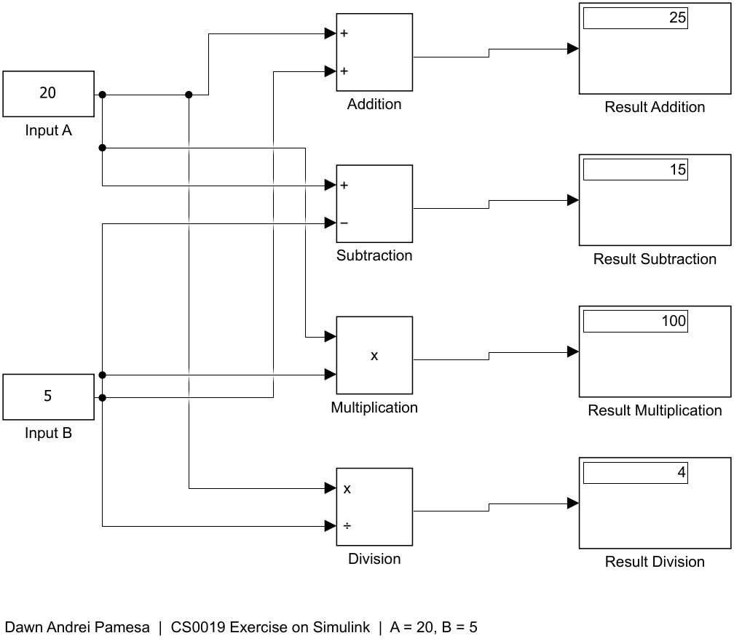
Results
Operation | Input A | Input B | Output
Addition | 20 | 5 | 25
Subtraction | 20 | 5 | 15
Multiplication | 20 | 5 | 100
Division | 20 | 5 | 4

